**Section 1: Error-Driven Learning in Java**

**Snippet 1:**

public class Main {

public void main(String[] args) {

System.out.println("Hello, World!");

}

}

**Error:-**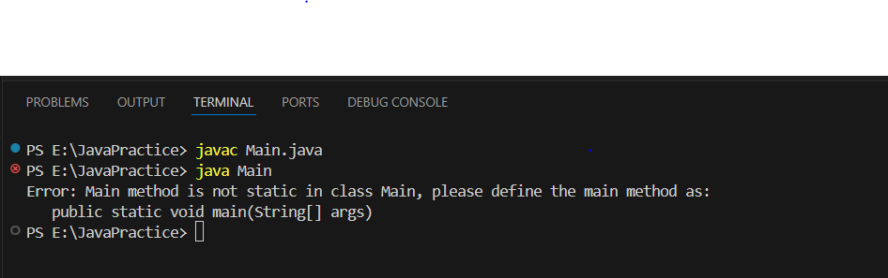

**Corrected Code:**

public class Main {

public **static** void main(String[] args){

System.out.println("Hello, World!");

}

}

**Output:**

**Hello, World!**

**Reason:**Main method is not static in class Main, main method as:

public static void main(String[] args)

**Snippet 2:**

public class Main

{

static void main(String[] args) {

System.out.println("Hello, World!");

}

}

**Error:-**

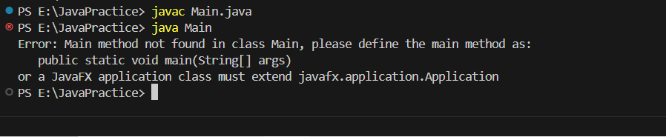

**Corrected Answer:-**

public class Main {

**public** static void main(String[] args) {

System.out.println("Hello, World!");

}

}

Reason :-

Main method not found in class Main, please define the main method as:

public static void main(String[] args)

**Snippet 3:**

public class Main {

public static int main(String[] args) {

System.out.println("Hello, World!");

return 0;

}

**Error:**

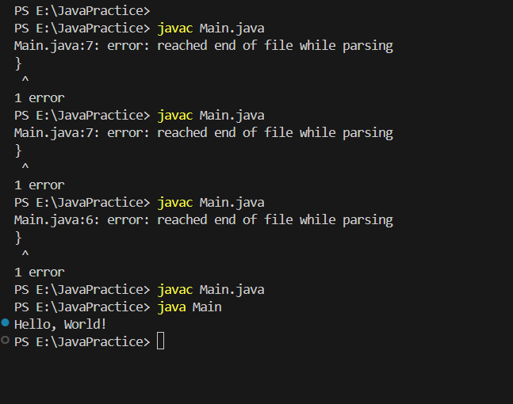

**Corrected Answer:**

public class Main {

public static void main(String args[]) {

System.out.println("Hello, World!");

}

}

**Reason:-**

**Snippet 4:**

public class Main {

public static void main() {

System.out.println("Hello, World!");

}

}

Error:-

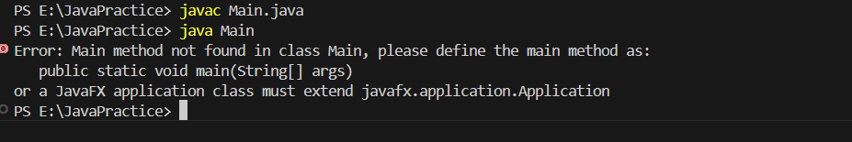

Corrected Answer:-

public class Main {

public static void main(String args[]) {

System.out.println("Hello, World!");

}

}

Reason:-

The Main method is missing as String args[]

Snippet 5:

public class Main {

public static void main(String[] args) {

System.out.println("Main method with String[] args");

}

public static void main(int[] args) {

System.out.println("Overloaded main method with int[] args");

}

}

Snippet 6:

public class Main {

public static void main(String[] args) {

int x = y + 10;

System.out.println(x);

}

}

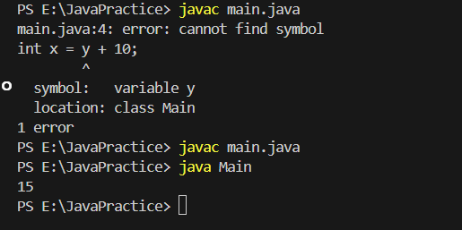

Corrected ans:-

public class Main {

public static void main(String[] args) {

int y = 5;

int x = y + 10;

System.out.println(x);

}

}

Reasoning:

Y is not initialise

Snippet 7:

public class Main {

public static void main(String[] args) {

int x = "Hello";

System.out.println(x);

}

}

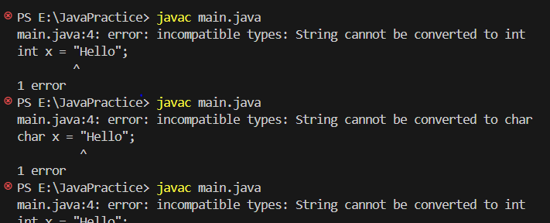

public class Main {

public static void main(String[] args) {

String x = "Hello";

System.out.println(x);

}

}

Reason:

Int cannot be converted to string

Snippet 8:

public class Main {

public static void main(String[] args) {

System.out.println("Hello, World!"

}

}

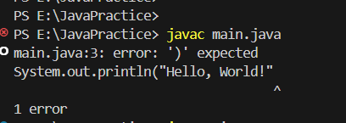

public class Main {

public static void main(String[] args) {

System.out.println("Hello, World!");

}

}

Reason

Print method expected bracket

Snippet 9:

public class Main {

public static void main(String[] args) {

int class = 10;

System.out.println(class);

}

}

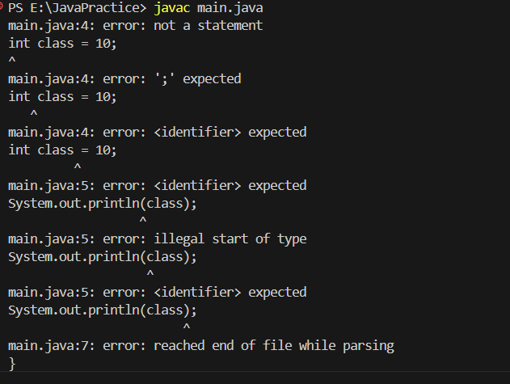

Snippet 10:

public class Main {

public void display() {

System.out.println("No parameters");

}

public void display(int num) {

System.out.println("With parameter: " + num);

}

public static void main(String[] args) {

display();

display(5);

}

}

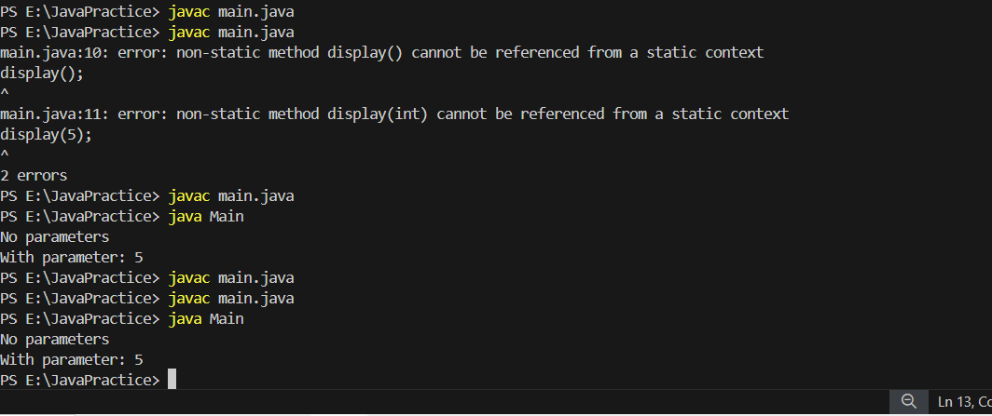

public class Main {

public static void display() {

System.out.println("No parameters");

}

public static void display(int num) {

System.out.println("With parameter: " + num);

}

public static void main(String[] args) {

display();

display(5);

}

}

Snippet 11:

public class Main {

public static void main(String[] args) {

int[] arr = {1, 2, 3};

System.out.println(arr[5]);

}

}

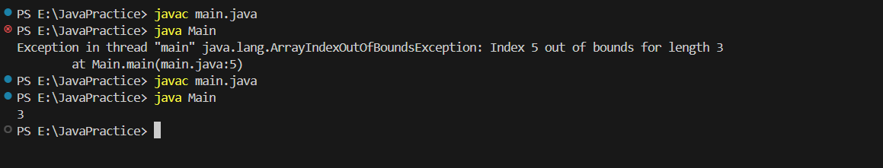

public class Main {

public static void main(String[] args) {

int[] arr = {1, 2, 3};

System.out.println(arr[2]);

}

}

Reason:-we providing value 5 thats why its going array out of bonds

Snippet 12:

public class Main {

public static void main(String[] args) {

while (true) {

System.out.println("Infinite Loop");

}

}

}

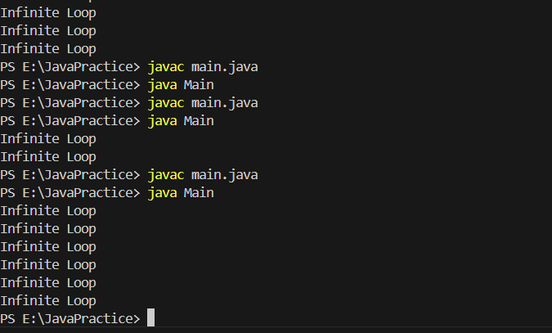

public class Main {

public static void main(String[] args) {

while (true) {

System.out.println("Infinite Loop");

}

}

}

public class Main {

public static void main(String[] args) {

int a=10;

while (a>=5 ) {

System.out.println("Infinite Loop");

a--;

}

}

}

Snippet 13:

public class Main {

public static void main(String[] args) {

String str = null;

System.out.println(str.length());

}

}

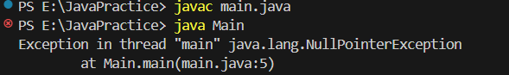

public class Main {

public static void main(String[] args) {

String str = "Mohini";

System.out.println(str.length());

}

}

Snippet 14:

public class Main {

public static void main(String[] args) {

double num = "Hello";

System.out.println(num);

}

}

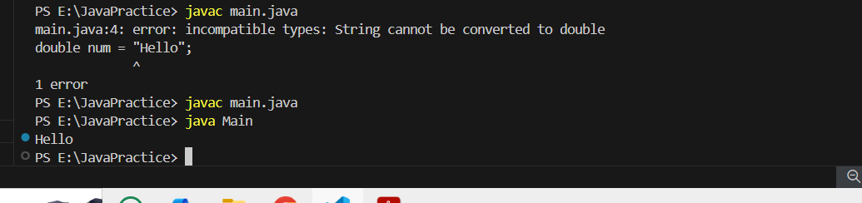

public class Main {

public static void main(String[] args) {

String num = "Hello";

System.out.println(num);

}

}

String cannot be converted to double

**Snippet**:

public class Main {

public static void main(String[] args) {

int num1 = 10;

double num2 = 5.5;

int result = num1 + num2;

System.out.println(result);

}

}

**Error**

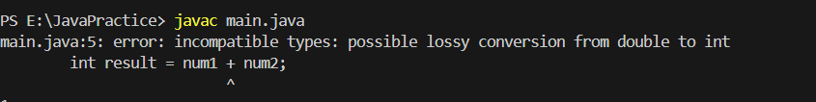

**Corrected Code**

public class Main {

public static void main(String[] args) {

int num1 = 10;

double num2 = 5.5;

double result = num1 + num2;

System.out.println(result);

}

}

**Reason**

Java does not allow implicit type conversion double to int

Snippet 17:

public class Main {

public static void main(String[] args) {

int a = 10;

int b = 5;

int result = a ** b;

System.out.println(result);

}

}

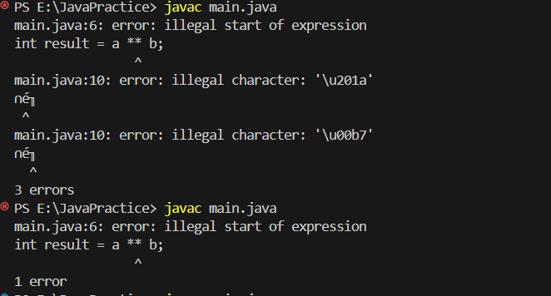

public class Main {

public static void main(String[] args) {

int a = 10;

int b = 5;

int result = a * b;

System.out.println(result);

}

}

illegal start of expression

int result = a ** b;

Snippet 18:

public class Main {

public static void main(String[] args) {

int a = 10;

int b = 5;

int result = a + b * 2;

System.out.println(result);

}

}

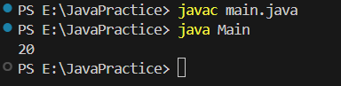

public class Main {

public static void main(String[] args) {

int a = 10;

int b = 5;

int result = a + b * 2;

System.out.println(result);

}

}

a=10;

b=5

10+(5*2)

First will solved bracket

Snippet 19:

public class Main {

public static void main(String[] args) {

int a = 10;

int b = 0;

int result = a / b;

System.out.println(result);

}

}

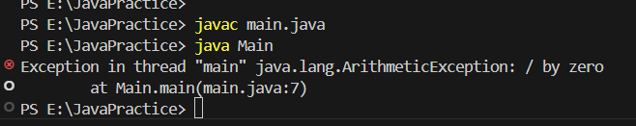

public class Main {

public static void main(String[] args) {

int a = 10;

int b = 0;

if (b != 0) {

int result = a / b;

System.out.println(result);

} else {

System.out.println("Error: Division by zero is not allowed.");

}

}

}

Snippet 20:

public class Main {

public static void main(String[] args) {

System.out.println("Hello, World")

}

}

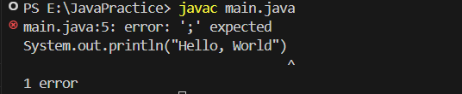

public class Main {

public static void main(String[] args) {

System.out.println("Hello, World");

}

}

Snippet 21:

public class Main {

public static void main(String[] args) {

System.out.println("Hello, World!");

// Missing closing brace here

}

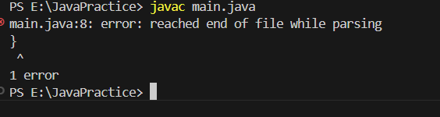

public class Main {

public static void main(String[] args) {

System.out.println("Hello, World!");

}

}

Snippet 22:

public class Main {

public static void main(String[] args) {

static void displayMessage() {

System.out.println("Message");

}

}

}

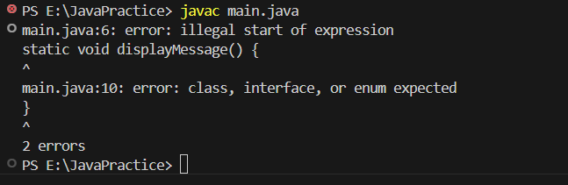

public class Main {

public static void main(String[] args)

{

}

static void displayMessage() {

System.out.println("Message");

}

}

Snippet 23:

public class Confusion {

public static void main(String[] args) {

int value = 2;

switch(value) {

case 1:

System.out.println("Value is 1");

case 2:

System.out.println("Value is 2");

case 3:

System.out.println("Value is 3");

default:

System.out.println("Default case");

}

}

}

Snippet 24:

public class MissingBreakCase {

public static void main(String[] args) {

int level = 1;

switch(level) {

case 1:

System.out.println("Level 1");

case 2:

System.out.println("Level 2");

case 3:

System.out.println("Level 3");

default:

System.out.println("Unknown level");

}

}

}